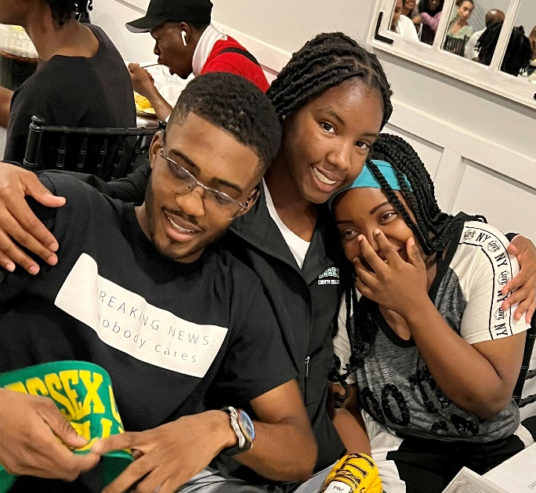
E.O.F. Matters – September ’22
The Monthly Newsletter from the Educational Opportunity Fund Program at Essex!
What’s New!
<<<<Congratulations to the PreFreshman Summer Program Students --- the newest ECC students had a great time learning, enjoying <<<<<<<<<<trips and bonding!!!!
Find out what’s happening at Essex at the EOF Forum: Kick Off ’22 ---- September 20 – 2pm in person in Siegler Hall and September 21 at 4:30pm - on Zoom: 8853059281 -- choose which day and time is best for you! We produce these forums to help you succeed – that’s why we make it mandatory --- All EOF students must attend the Forums – we have to different days and times so you can fit it into your schedules ! Hey – It’s good for you!
Classes start this Thursday – September 1! You can still get in September 1 – 9 So come over!
What is Fall II? Staring September 26, Monday – a group of new classes will be available for you --- you can add in the classes!!! Our Fall II semester starts on Oct 6
As for the EOF Department --- Mike Cresci is our newest Program Manager, Ms. Edyta Niedbol is now the Eligibility Coordinator! Solange Amaya, is newish advisor for General Science Student --- so we are here for you --- daily from 8:30am to 6pm!
Are I still EOF???? Please note that you do not have to reapply for EOF funding as long as you remain full time and are in good standing. In the event that you are not – please come to see your EOF Counselor and see if it makes sense to go part time
The fabulous EOF Tutors are set to return the first week in September --- so come on over and get with them! Also, this is a friendly reminder that part of your obligation as an esteemed EOFer, is that you are to come and USE! the program services --- so come on in for advice, chit-chat and snacks ---
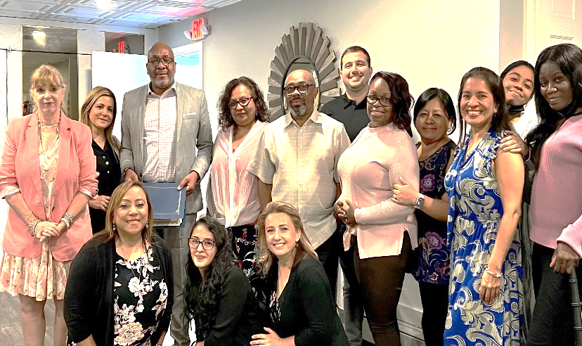
General Science Students --- EOF will pay for you to take the Preparation Course for ATI – TEAS Test! Put your best foot forward as you get ready to apply for programs such as Physical Therapy; Radiography; Nursing: Learn more --- see Ms. Solange in EOF – 973 877-33360!
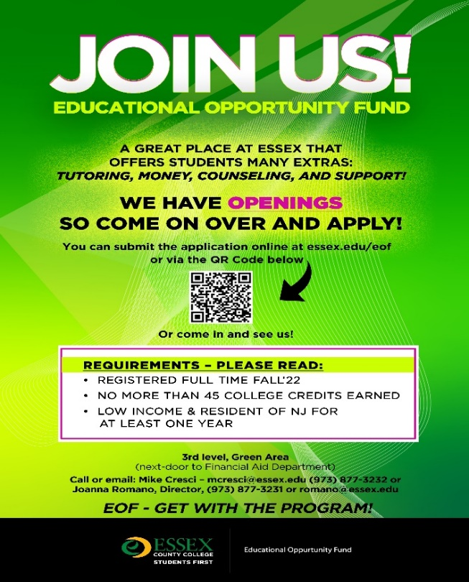
<<<<Share the wealth --- get your friends, classmates, to apply for EOF – more money and services to help them to reach their goals!!!
Coach Tracy Cooper is here to help you decide on your career goals!!! Don’t miss this opportunity to have 1 -1 sessions to find matches for your talents, your future lifestyle hopes and the job market!!!908 977-6811 tracycoopercoacha2gmail.com
Mark your calendars for these exciting events:
Transferring!!! Where Should I Go???
Tuesday, October 18 @ 2:30pm (Siegler Hall) and Wednesday, October 20 @ 4:30pm
(virtual) ID: 8853059281
Hot Careers !!! Tuesday, November 15 @ 2:30pm (Siegler Hall) and Wednesday, November 16 @ 4:30pm (virtual) ID: 8853059281
Multicultural Celebration --- Many People – One World!!! December 15 at 2:30PM (Siegler Hall)
In the works also……Wellness Wednesdays!; LinkIn Workshop; Classroom Tech Guide; Invitations to our chapter of National Society of Student leadership (NSLS); Alumni Gathering --- what are your ideas on how we can continue to support you?? Contact us – Joanna Romano, Director – 9783 877-3231 or Caroline Beretta, Associate Director; x3405! EOF – Get with the Program!!!

