
Community, Continuing Education, Workforce development and Library Services Area
The Educational Opportunity Fund Program
EOF at Essex
E.O.F. Matters – November ‘22
The Monthly Newsletter from EOF at ECC!*
Yes! November is a big month for Students and Staff!!!
Here are some important dates:
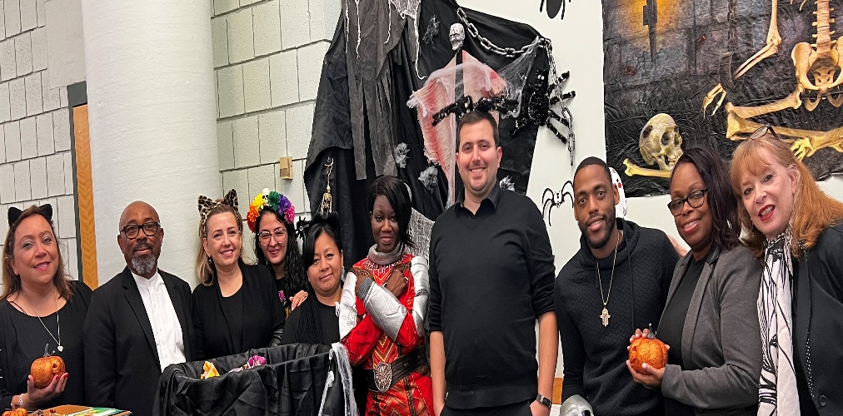
Vote – November 8!!!
- Nov 18 – Last day to withdraw
- Dec 20 –last day of classes
- Thanksgiving --- 24, 25 – College Closed
- Dec 23 --- 1st day of Winter Intersession – check in with your EOF
Counselor to get your tuition paid!!!
Come on over – or call us to get extra help with your studies:
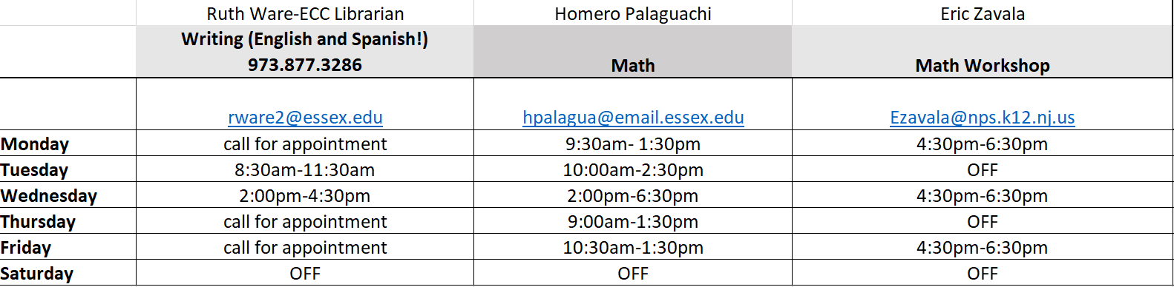

Congratulations to our own David Hill, a graduate of ECC and an EOF alumn!!! He was recently promoted to Deanof Student Affairs at St Elizabeth’s University!!!
Wellness Wednesdays! Join us for mediation, green tea, and TLC!!! 12:30 in EOF Department – all are welcomed!

Great News --- Career Coach Tracy Cooper is back with us to work with you on your career goals ---- she can help you decide what you want to be when you grow up (LOL) and also help with your resume, cover letters, Linked in accounts etc…. 908 977-6811 call for your very own appointment!
Job Opening – Right here in EOF --- Learning Associate needed for English and Chemistry ---- call or see Mike --- x3232!!!

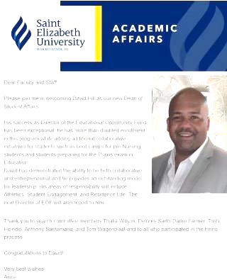
Alumni news-----
Dean David Hill! ---- Congratulations to David for his promotion to Dean of Student Affairs at St. Elizabeth University!!! He is a devoted EOF and ECC alum!!

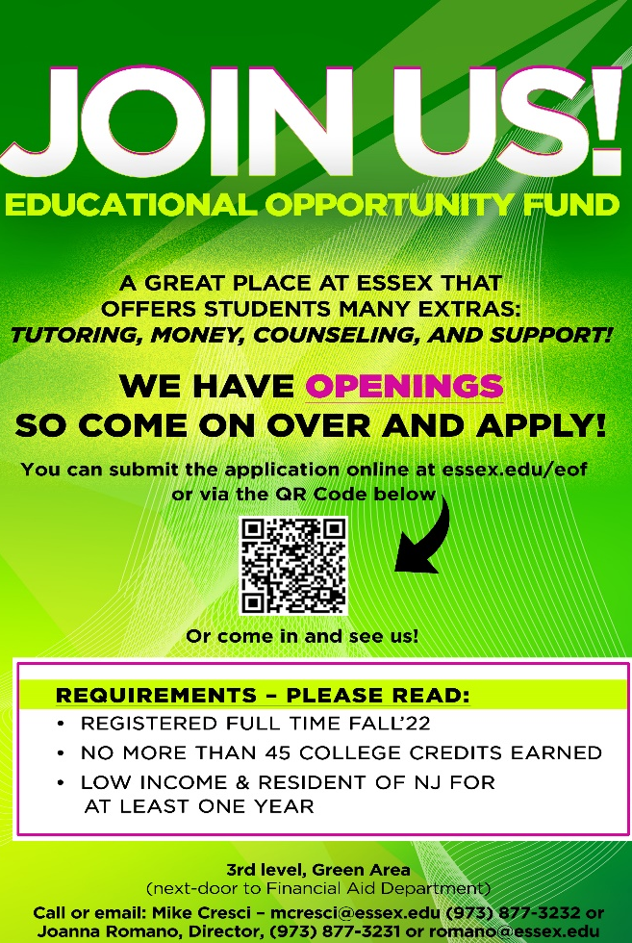

*EOF is a State of NJ and ECC sponsored support department for college students who hail from low income background --- Learn more: essex.edu/eof; visit – 3rd level, green Area!
EOF – Get with the Program!!!!

